DRAFT SAMPLE EXAMINATION
MARKING KEY
STAGE 3

2008/20487
CHEMISTRY — ANALYTIC MARKING KEY STAGE 3 PAPER

SECTION 1 — MULTIPLE-CHOICE

Question No | Answer
1. | A
2. | C
3. | C
4. | B
5. | C
6. | B
7. | A
8. | C
9. | D
10. | B
11. | D
12. | C
13. | A
14. | D
15. | C
16. | A
17. | C
18. | B
19. | D
20. | D
21. | B
22. | C
23. | B
24. | C
25. | D

Question 1
(8 marks)

(a) Lead nitrate solution is mixed with a sodium sulphate solution.
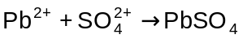

(b) Dilute sulphuric acid solution is added solid barium oxide.

2 H⁺ + BaO → Ba2⁺ + H₂O

(c) Butane is burnt in air

2 C₄H₁₀ + 9 O₂ → 8CO₂ + 10 H₂O

(d) Silver nitrate solution is added dropwise to a solution of iron (III) nitrate

‘no reaction’

Question 2
(8 marks)

(a) Acidified potassium permanganate solution is added dropwise to ethanol.

The purple permanganate is decolourised.

(b) Barium sulfate solution is mixed with sodium carbonate solution.

A white precipitate forms.

(c) Dilute sulfuric acid solution is added to a solution of potassium chromate.

The yellow solution turns orange.

(d) Sodium hydroxide solution is added to a 2mol L⁻¹ solution of ammonium nitrate and the mixture is gently heated.

A pungent odour is produced.

2 marks for each answer for a total of 8 marks
Mark | Description
2 | An accurate observation not an inference
1 | Gives an accurate observation and names the product of the reaction
0 | Question incorrectly answered or not attempted.
Question 3
(9 marks)

 | Species | Structural formula  (showing all valence shell electrons) | Marks
 | Ammonium chloride,  NH₄C | . .  . .  :  :  +  H  N  H  H  H  O  O  O  C  :  :  :  :  :  :  :  . .  . .  . .  . .  . .  2-  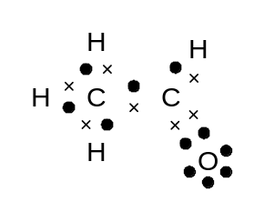 | For full marks  - brackets and charge
 | Carbonate ion,  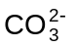 |  | For full marks  - brackets and charge  - correct number of valence electrons
 | Ethanal,  (acetaldehyde),  CH₃CHO |  | For full marks  - oxygen has the correct number of valence electrons

For 3 marks for each answer

Mark | Description
3 | The correct structure must be drawn showing all valence electrons
2 | Correct structure, but one pair of valence electrons not shown or charge on the ion not shown
1 | Correct structure, but no more than two pairs of valence electrons not shown or no charge shown or brackets omitted
0 | Question incorrectly answered or not attempted.

Question 4
(10 marks)

(a)
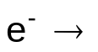
Zinc
Copper
Salt bridge
Zn²⁺
Cu²⁺
1.20 V

0.97

V
Anode
Cathode
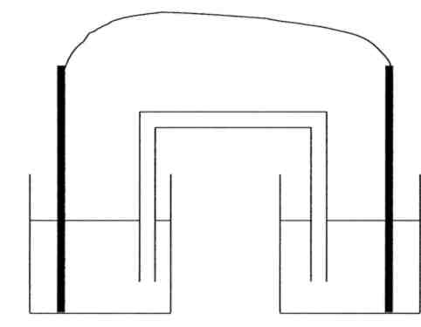

Mark | Description
3 | Both labels are correct and the direction of movement of ions and electrons correct
1–2 | One mark awarded for each correctly completed part
0 | Question incorrectly answered or not attempted.

(b)
(i) anode reaction Zn → 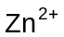 + 2 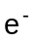
(iii) cathode reaction 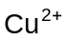 + 2 → Cu

Mark | Description
2 | Correctly balanced anode and cathode reactions
1 | Correctly balances one of the electrode reactions
0 | Question incorrectly answered or not attempted.

(c)
The main requirements are
- The salt does not form a precipitate with any of the ions in the half cells
- The ions in the salt bridge cannot take part in the redox reaction.

Salts that are used in salt bridges include potassium nitrate potassium chloride.

Mark | Description
3 | Both requirements and a correct salt are given
2 | Only the requirements are given or one requirement and a salt is given
1 | Only one requirement or one salt is given
0 | Question incorrectly answered or not attempted.
(d)
The table of Standard Reduction Potentials is based on solution concentrations of 1 mol L-1 in this problem the solutions were 2 mol L-1.

Mark | Description
2 | Correctly identifies that the table is based on a concentrations of 1 mol L⁻¹ and in this electrochemical cell the concentrations were 2 mol L⁻¹
1 | States that the concentrations in this electrochemical cell are different to those in the Table of Standard Reduction Potentials
0 | Question incorrectly answered or not attempted.
Question 5
(7 marks)

(a)

Compound | Is H-bonding present?  (yes or no)
CH₃NH₂ | Y
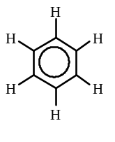 | N
CH₃CH₂CH₂F | N
CH₃COOH | Y
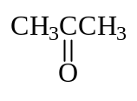 | N

Mark | Description
5 | One mark for each correct response

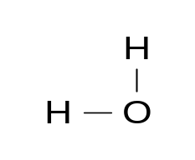
(b)

Hydrogen bond
(+)
(+)
(+)
(+)
(–)
(–)

Mark | Description
2 | Correctly shows the H-bond and indicates the polarity of the bonds
1 | Only one shows the H-bond
0 | Question incorrectly answered or not attempted.
Question 6
(9 marks)
heat
(a)
2 NH₄C + Ca(OH)₂ → NH_{3(g)} + CaC₂ + 2H₂O

Moles of NH₄C = 4.65 = 9.40 x 10⁻²
49.46

Moles of Ca(OH)₂ = 6.64 = 8.29 x 10⁻²
74.09

Taking the stoichiometric ratio into account

9.40 x 10⁻² moles of NH₄C will react with (9.40 x 10⁻² ÷ 2) 4.75 x 10⁻² moles of Ca(OH)₂

The limiting reagent is NH₄C.

Mark | Description
5 | Correctly identifies the limiting reagent showing sufficient working to justify choice
4 | Correctly identifies the limiting reagent showing sufficient working, but makes a simple error in the calculations
2 | Identifies the incorrect limiting because they did not take the stoichiometric ratio into account
1 | Calculates the number of moles of either reagant
0 | Question incorrectly answered or not attempted.
(b)
Moist red litmus paper can be used. Red litmus will turn blue.

The ammonia gas reacts with water to produce hydroxide ions.

NH₃ + H₂O → 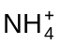 + 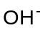

The hydroxide ions turn the blue litmus red.

Mark | Description
4 | Correctly describes a simple test and observation with a balanced equation
3 | Correctly describes a simple test and observation without a balanced equation
2 | Only provides a test and an observation
1 | Only provides a test or an observation
0 | Question incorrectly answered or not attempted.

Question 7
(8 marks)

(a)
False
At dynamic equilibrium the rate of the forward and reverse reactions are equal, not the number of molecule of each species.

Mark | Description
2 | Identifies the correct answer and gives an explanation
1 | Answer TRUE, but gives an explanation that supports the answer
0 | Question incorrectly answered or not attempted.

When Lim halved the volume of the gas in the cylinder by pushing the plunger downwards he recorded his observations.

(b)
Observation A
When the volume is halved the partial pressure (concentration) of both gases increases. The increase impartial pressure (concentration) of NO₂ produces a darkening of the colour of the gas.

Mark | Description
2 | Explains the observation and gives an answer in terms of partial pressure
1 | Explains the observation only in terms of concentration.
0 | Question incorrectly answered or not attempted.
Observation B
The forward reaction is favoured by an increase in pressure, lowering the concentration of NO₂. The lowering of the [NO₂] reduces the intensity of the colour of the gas mixture.

Mark | Description
2 | Explains the observation and gives an answer in terms of equilibrium shifting to the left lowering the [NO₂] reducing the intensity of the colour of the gas mixture
1 | Explains the observation only in terms of lowering the pressure
0 | Question incorrectly answered or not attempted.
(c) When equilibrium is re-established and the system now has a reduced volume, the concentrations of both gases is higher and as a consequence the equilibrium mixture is darker due to a higher [NO₂].

Mark | Description
2 | Correctly identifies that the colour would be darker due to the increased  concentration of NO₂
1 | Explains the observation only in terms of concentration
0 | Question incorrectly answered or not attempted.
Question 8
(6 marks)

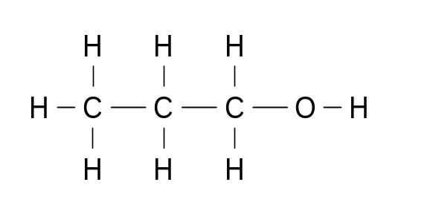
(a) (i)
1-propanol
2-propanol
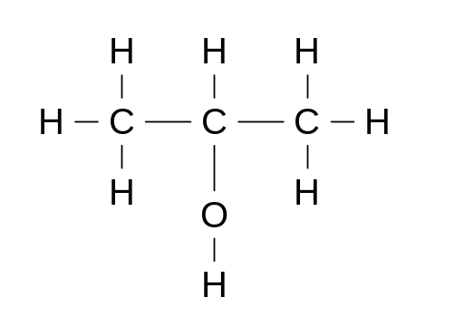

(ii)

Mark | Description
4 | One mark each for each correct response
1- 3 | One mark each for each correct response, one mark deducted for not using H to indicate a hydrogen attached to a carbon atom or naming 1- propanol as propanol.
0 | Question incorrectly answered or not attempted.

(b)
Complete the table below by writing the name of the alcohol in one column and the name of the oxidation product in the other column.
.
Name of alcohol | Name of oxidation product
Isomer 1  1-propanol | propanoic acid  or  propanal
Isomer 2  2-propanol | propanone

Mark | Description
2 | One mark each for each correct response
0 | Question incorrectly answered or not attempted.

Question 9 (7 marks)

Acetic (ethanoic) acid is a weak acid and exists in an aqueous equilibrium shown in the equation below.

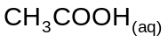 + H₂O_{(l)} + heat ⇌ 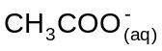 + 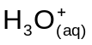

(a) Write an equilibrium expression for this reaction

K = [CH₃COO- ] [H₃O+]
[CH₃COOH]

Mark | Description
2 | Expression for K correctly written
1 | Expression written with water included or the inverse expression with water being included
0 | Question incorrectly answered or not attempted.

(b) The value of K in this system is 1.78 x 10⁻⁵ at 25 °C.
If the temperature is increased to 40 °C, will the value of K increase, stay the same or decrease?

The value of K increases

- The forward reaction is endothermic
- Increasing the temperature favours the forward reaction
- When equilibrium is re-established at the higher temperature the
[CH₃COO- ] and [H₃O+] have increased while the [CH₃COOH] has decreased
- When the value of K is calculated using the new concentration a larger value of K is arrived at.

Mark | Description
4 | Correctly identifies the change in the value of K  Describes the effect of temperature on position of equilibrium  States that the system comes to equilibrium at a higher temperature Explains the effect that the change concentration has on the value of K
3 | Correctly identifies the change in the value of K  Describes the effect of temperature on position of equilibrium  Explains the effect that the change concentration has on the value of K
2 | Correctly identifies the change in the value of K  States that higher concentrations of 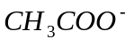(aq) and 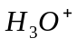(aq) give a higher value of K
1 | States that the increase in temperature increases the value of K
0 | Question incorrectly answered or not attempted.
SECTION 3 — EXTENDED RESPONSE
(15 marks)

Question 1
The pH of blood is maintained through buffering. The major buffer system present in blood is based on a carbonic acid/hydrogencarbonate ion buffer. The presence of these substances keep the pH of blood to about 7.4.

When carbon dioxide enters the blood stream as a product of cellular respiration as shown in equation (i), the following reactions occur:
(i) C₆H₁₂O₆ (aq) + 6 O₂ (aq) → 6 CO₂ (aq) + 6 H₂O ()

(ii) CO₂ (aq) + H₂O () ⇌ 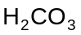 (aq)
(iii) (aq) ⇌ 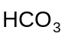(aq) + 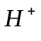(aq)
(iv) CO₂ (aq) ⇌ CO₂ (g) (this equation (iv) occurs in the lungs)

(a) If the pH of blood is normally 7.4 calculate the [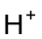]
pH = - log [] If pH = 7.4

[] = 3.9 x 10⁻ ⁸

Mark | Description
2 | Correctly calculates the value of []
1 | The answer is incorrect, but sufficient working is shown to indicate that the error was in the incorrect use of the calculator
0 | Question incorrectly answered or not attempted.

(b) Write an equilibrium expression K for reaction (ii)

K = [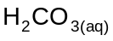]
[CO_{2(aq)} ]

Mark | Description
2 | Expression for K correctly written.
1 | Expression written with water included or the inverse expression with water being included.
0 | Question incorrectly answered or not attempted.

(c) Hyperventilation, or rapid breathing, decreases the amount of carbon dioxide in the lungs and therefore the concentration of carbon dioxide dissolved in the blood. This leads to changes in the pH of the blood.

(i) Indicate if the following statement is true or false.
Hyperventilation will lower the pH of the blood.
Circle the correct response. True False
(1 mark)
(ii) Explain, using the equations provided, the reason for the initial change in the pH of the blood.

    - If the [CO₂ (aq) ] is lowered then the position of the equilibrium in equation (ii) will shift to the left lowering [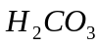(aq)]
    - The position of the equilibrium in equation (iii) will also shift to the left
    - Lowering [(aq)] and lowering the [(aq)] raises the pH

Mark | Description
4 | Correctly identifies that the statement is false  States all 3 points that lead to raising the pH
3 | Correctly identifies that the statement is false.  States that the position of the equilibrium in equation (ii) will shift to the left lowering [(aq)]  A lowering of [(aq)] lowers [(aq)]raising the pH
2 | Correctly identifies that the statement is false  States that a lowering of CO₂ (aq) lowers [(aq)] raising the pH
1 | Correctly identifies that the statement is false
0 | Question incorrectly answered or not attempted.

(d) Strenuous activity increases the rate of respiration. Explain the effect that an increase in the rate of respiration has on the pH of blood, using the equations provided.

Strenuous activity
    - Increases the [CO₂ (aq)] The position of equilibrium in reaction (ii) shifts to the right raising [(aq)]
- The position of the equilibrium in equation shifts to the right increasing the [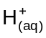]
- The increase in [(aq)] lowers the pH

Mark | Description
3 | Identifies that the pH of the blood is lowered  Explains how the shift in equilibrium position results in a higher [(aq)]  States that a higher [(aq)] means a lower pH
2 | Identifies that the pH of the blood is lowered  States that a higher [CO₂ (aq) ] will make the blood more acidic
1 | States that the pH of the blood is lowered
0 | Question incorrectly answered or not attempted.

(e) The 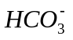(aq) ion is an effective buffer in both acidic and basic solutions. Explain how this is possible using equations to support your answer.

The (aq) ion is able to act as either an acid or a base.

(aq) + H⁺ → H₂CO₃ (base)

or

(aq) + OH⁻ → CO₃ ⁻² + H₂O (acid)

Mark | Description
2 | Both equations are correct
1 | One correct equation
0 | Question incorrectly answered or not attempted.
Question 2 (13 marks)

Olive oil and grape-seed oil have similar structural formula

Olive oil CH₃(CH₂)₄CH₂CH₂CH₂CH=CH(CH₂)₇COOH
(Formula mass 282.45g)

Grapeseed oil CH₃(CH₂)₄CH=CHCH₂CH=CH(CH₂)₇COOH
(Formula mass 280.44g)

Unsaturated oils can be converted into saturated oils by reacting the oil with hydrogen gas in the presence of a palladium catalyst.

A batch of olive oil was suspected to have had grapeseed oil accidentally added to it. To test the purity of the olive oil, a chemist hydrogenated a 19.74 g sample of oil. It required 835 mL of hydrogen gas at 150 ⁰C and (300.0 kPa) to completely hydrogenate the oil sample.

(a) Explain with the aid of simple equations why olive oil and grapeseed oil would require different volumes of hydrogen to completely saturate 1 mole of each of the oils

CH₃(CH₂)₇CH=CH(CH₂)₇COOH + H₂ → CH₃(CH₂)₇CH₂CH₂(CH₂)₇COOH
(1 mole of hydrogen per mole of olive oil)

CH₃(CH₂)₄CH=CHCH₂CH=CH(CH₂)₇COOH + 2 H₂ →

CH₃(CH₂)₄CH₂CH₂CH₂CH₂ CH₂(CH₂)₇COOH
(2 moles of hydrogen per mole of grapeseed oil)

Grapeseed oil has 2 double bonds and requires twice the volume of hydrogen that olive oil requires to saturate one mole of oil.

Mark | Description
3 | Correctly balances both equations and uses the mole ratio to explain why grapeseed oil requires a greater volume of hydrogen
2 | Correctly balances both equations and states that grapeseed oil needs more hydrogen
1 | Balances one of the equations
0 | Question incorrectly answered or not attempted.

(b) Calculate the volume of hydrogen at 150 °C and (300.0 kPa) needed to completely hydrogenate a 19.74g of pure olive oil.

N⁰ moles of olive oil = 19.74
282.45

= 6.989 x 10⁻²

PV = n RT

V = 6.989 x 10⁻² x 8.315 x (273+ 150)
300

= 819 mL

Mark | Description
5 | Correctly calculates the volume of hydrogen required
4 | Calculates a volume but makes one error due to incorrect manipulation of the variables in the ideal gas equation
3 | Calculates a volume but makes one error in the calculation due to using the incorrect value for R, or fails to convert temperature to Kelvin
1 | Correctly calculates the number of moles of olive oil
0 | Answer to (i) is correct.

(c) Answer these questions using the information that you have been given and the answer from (b):

(i) Has the olive oil been contaminated with grapeseed oil?

Yes the oil has been contaminated with grapeseed oil.

(ii) Give a brief explanation in support of your answer. A calculation is not required.

If the sample of olive oil was pure it would have only required 819.mL of hydrogen.
Grapeseed oil requires more hydrogen than olive oil and the results indicate the presence of grapeseed oil.

Mark | Description
3 | Answer to (i) is correct and the explanation supports the answer that is given
2 | The answer to (i) is correct but does not fully explain why the addition of grape seed oil would mean that a greater volume of hydrogen would be required
1 | Answer to (i) is correct
0 | Answer to (i) is correct.

Question 3 (11 marks)

A student investigates the effect of the concentration of hydrochloric acid on the rate of oxidation of zinc in the laboratory. She adds 40.0 mL of 1.00 mol L⁻¹ hydrochloric acid to 20.0 g of zinc in a conical flask and measures the rate at which hydrogen is given off.

Time | 0 | 0.5 | 1.0 | 1.5 | 2.0 | 3.0 | 5.0 | 7.0 | 8.0 | 10.0
(min)
Loss in | 0 | 0.19 | 0.35 | 0.47 | 0.63 | 0.72 | 0.82 | 0.86 | 0.88 | 0.88
mass (g)

The flask and contents were immediately weighed and a stopwatch started. The mass of the flask and contents were noted as the reaction proceeded. The table indicates the loss in mass at various times.

(i) List two variables you would expect to control in this experiment.

- temperature
- volume of acid that is added
- mass of zinc.
Mark | Description
2 | Correctly identifies two variables that should be controlled
1 | Identifies one variable that should be controlled
0 | Question incorrectly answered or not attempted.
(ii) List one variable you have to measure and ONE other variable that you
could measure to determine the rate of reaction.
Variable you have to measure Time
Variable that you could measure Loss of mass, volume of hydrogen evolved.

Mark | Description
2 | Correctly identifies one variable that could be measured and one variable that could be measured
1 | Only identifies one variable correctly
0 | Question incorrectly answered or not attempted.

(iii) Plot a graph of 'loss in mass' against time, on the grid on page.

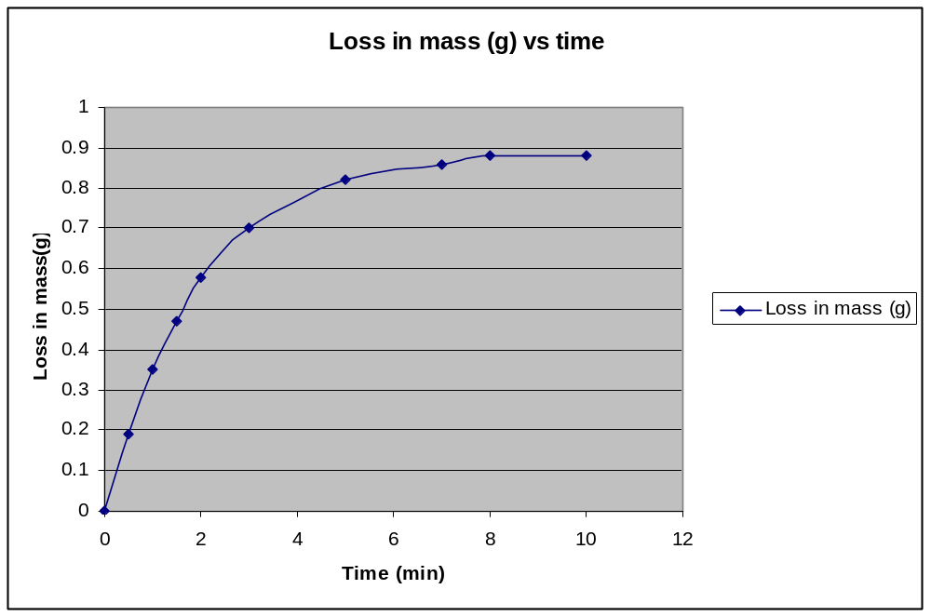
Mark | Description
5 | The graph has:  - correctly labelled both axes  - the data has been plotted accurately  - an appropriate scale has been selected  - the graph has a title.
3 - 4 | The graph has:  - correctly labelled axis.  - the data has been plotted accurately  - an appropriate scale has been selected  - the graph has a title.
2 | The graph has:  - correctly labelled axes  - the data has been plotted accurately.
0 | Question incorrectly answered or not attempted.

(iii) List two potential sources of uncertainty in experimental measurements in this investigation and how you would minimise them.

- Volume measurement use pipette or burette
- Mass measurement use an electronic mass that measures to 0.001g
- Measure time in seconds
- Concentration of acid use a standardised solution.

Question 4 (12 marks)
Mark | Description
2 | Two sources of uncertainty that would have an effect on the accuracy of the experiment have been identified
1 | A source of uncertainty that would have an effect on the accuracy of the experiment has been identified
0 | Question incorrectly answered or not attempted.

When copper(II)sulfate is dissolved in water a blue coloured solution of 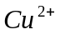(aq) ions are formed and when treated with excess concentrated ammonia solution the initial precipitate of copper hydroxide dissolves to give a deep blue solution. When ethanol is added to the solutions deep blue crystals precipitate. When the solution is filtered the crystals smell of ammonia, and an unstable salt with formula Cu(NH₃)_{x}SO₄.yH₂O has been formed.

(a) When 1⋅4009 g of the unstable salt is heated at 300°C, the salt decomposes and the ammonia is driven off. The ammonia that is produced is captured and found to occupy 508⋅1 mL at STP. Calculate the number of moles of ammonia (x) in the 1⋅4009g sample of the complex salt.

Moles of NH₃

PV = nRT

n = PV
RT

= 101.3 x .0.5081
8.315 x 273

= 2.27x 10⁻³ moles of NH₃

Mark | Description
2 | Calculates correct number of moles of ammonia
1 | Calculates a value, does not use the correct volume or value for R
0 | Question incorrectly answered or not attempted.

(b) Calculate the mass of the ammonia in the 1.4009 g sample.

Mass of NH₃

n = mass
formula mass

mass NH₃ = 2.27x 10⁻³ x (14 + (3x1.008))

= 0.386 g
Mark | Description
2 | Calculates the correct mass of ammonia
1 | Calculates a value, but makes one error in calculation
0 | Question incorrectly answered or not attempted.

(c) Another 1⋅4009 g of the unstable salt is heated at 300°C driving all off the ammonia and water leaving only 0.9055g of copper(II) sulfate behind. Calculate the mass of water in a 1.4009 g sample of the unstable salt.

Mass of water = mass of complex salt - mass of copper sulfate
and ammonia

= 1.4009 - 0.9055

= 0.4954 g

Mark | Description
3 | Calculates mass loss correctly recognising that this is a twostep process
1 | Calculates mass of water in one step
0 | Question incorrectly answered or not attempted.
(d) Calculate the number of moles of water in a 1⋅4009 g sample of the unstable salt.

Moles of water = 0.1094
in the sample 18.016

= 6.072 x 10⁻³

Mark | Description
1 | Correctly converts mass of water to moles of water
0 | Question incorrectly answered or not attempted.
(e) Calculate the number of moles of copper(II) sulfate in the 0.90551g sample of copper(II) sulfate.

Moles of copper = 0.9055
sulphate 159.5

= 5.677 x 10⁻³

Mark | Description
1 | Correctly converts mass of copper sulfate to moles of copper sulfate
0 | Question incorrectly answered or not attempted.

(f) Using the information from (a) to (e) determine the empirical formula of the unstable copper salt.

Empirical moles CuSO₄ moles NH₃ moles H₂O
formula 5.677 x 10⁻³ 2.267x 10⁻³ 6.072 x 10⁻³

Mole ratio 1 3.99 1.06

Empirical
formula CuSO₄ (NH₃)₄ .H₂O

Mark | Description
3 | Calculates the correct empirical formula
2 | Calculates an empirical formula using incorrect value/s from (a) – (e)
0 | Question incorrectly answered or not attempted.

Question 5 (12 marks)

Borax, Na₂B₄O₇.10H₂O, can be used as a primary standard in acid-base titrations. It reacts according to the following equation:

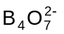 + 2H⁺ + 5H₂O → 4H₃BO₃

2.334 g of borax was dissolved in a 250.0 mL volumetric flask and the flask filled to the mark with distilled water. 20.00 mL aliquots of the borax solution were titrated against a hydrochloric acid solution and the following results were obtained.

 | 1 | 2 | 3 | 4
Final reading (mL) | 20.20 | 36.80 | 21.07 | 37.70
Initial reading (mL) | 2.55 | 20.20 | 4.35 | 21.07
Titration volume (mL) | 17.65 | 16.60 | 16.72 | 16.63

(a) Calculate the concentration of the borax solution.
Formula mass Na₂B₄O₇.10H₂O = 381.38g
n = 2.334
381.38

n = 6.119 x 10⁻³

c = n
V

= 6.119 x 10⁻³
0.250

= 2.447 x 10⁻² mol L⁻¹

Mark | Description
3 | Calculates the correct concentration and gives part of the description missing
2 | Calculates an answer but makes one error such as the incorrect determination of the molar mass of Na₂B₄O₇.10H₂O or not converting the volume to litres
1 | Correctly calculates the number of moles of Na₂B₄O₇.10H₂O
0 | Question incorrectly answered or not attempted.

(b) Complete the table and calculate the average titration volume.

Average volume = (16.60 + 16.72 + 16.63 ) ÷ 3 (17.65 outlier)

= 16.65 mL

Mark | Description
2 | Calculates the average volume and excludes the outlier (17.65 mL)
1 | Calculates the average volume and includes the outlier (17.65 mL
0 | Question incorrectly answered or not attempted.

(c) Calculate the concentration of the hydrochloric acid solution.

N⁰ of moles = 2 x 2.447 x 10⁻² x 20
in 20 mL 1000

= 4.895 x 10⁻⁴

Use stoichiometric ratio to find the number of moles of H⁺

= 2 x 4.895 x 10⁻⁴

= 9.790 x 10⁻⁴

Concentration HC = n
V

= 9.790 x 10⁻⁴
0.01665

= 5.88 x 10 ⁻² mol L⁻¹

Mark | Description
4 | Calculates the correct concentration of HC
3 | Calculates a concentration for HC, but makes one simple mathematical error in the calculation
2 | Calculates a concentration for HC, but fails to use the stoichiometric ratio  In the calculation
1 | Correctly calculates the number of moles of B₄O₇²
0 | Question incorrectly answered or not attempted.
(d) What two properties are required of a primary standard like borax?

Primary standard must be stable i.e.
- they must not absorb water or carbon dioxide from the atmosphere.
- the molar mass of the material must be high to reduce the weighing error.

Mark | Description
2 | Correctly identifies two properties of a primary standard
1 | Correctly identifies one property of a primary standard
0 | Question incorrectly answered or not attempted.

Question 6 (10 marks)

The following table gives information about the solubility of some solutes in the solvents water and hexane.

Solute | Solvent
Solute | Water | Hexane
methanol | soluble | slightly soluble
Pentan-1-ol | slightly soluble | soluble
sodium chloride | soluble | insoluble

(a) Discuss the type of and the relative strength of the intermolecular and or interionic forces displayed by each of the solutes. ( 6 marks)

Methanol has both H-bonding and dispersion forces. The hydrogen bonding between methanol and water is stronger than the dispersion forces methanol and hexane as indicated by their relative solubilities in the respective solvents.

Mark | Description for methanol
2 | Correctly identifies both types of intermolecular bonding and comments on their relative strength by relating it to its solubility in water
1 | Only identifies one of the intermolecular forces
0 | This part of the question incorrectly answered or not attempted.
Pentan-1-ol has both H-bonding and dispersion forces. The hydrogen bonding between
the pentan-1-ol and water is weaker than the dispersion forces between the hexane
as pentan-1-ol is only slightly soluble in water.

Mark | Description for pentan-1-ol
2 | Correctly identifies both types of intermolecular bonding and comments on their relative strength by relating it to its solubility in hexane
1 | Only identifies one of the intermolecular forces
0 | This part of the question incorrectly answered or not attempted.
Sodium chloride has strong electrostatic forces of attraction between oppositely charged ions.
The strength of the interionic attraction makes the sodium chloride insoluble in hexane.

Mark | Description for sodium chloride
2 | Correctly identifies electrostatic forces as the interionic force and comments on its strength by relating it to its insolubility in hexane
1 | Only states that the main interionic force is attraction between ions
0 | This part of the question incorrectly answered or not attempted.

(b) Account for the differences between the solubility of pentan-1-ol in water and hexane. [Hint like dissolves like is a statement and not an explanation.]

The pentan-1-ol molecule is able to generate H- bonds, however the long hydrocarbon chain limits the salvation process by reducing the ability of the molecules form hydrogen bonds with water molecules. The hydrocarbon chain because of the number of atoms is able to generate significant dispersion forces due to the electrons and nuclei. The forces between hexane molecules are dispersion forces and this enables the salvation process between
pentan-1-ol and hexane to occur.

Mark | Description
4 | States that  - pentan-1-ol has both H-bonding and dispersion forces  - identifies that there must be a factor that reduces the amount of H-bonding that can occur  States that:  - pentan-1-ol has both H-bonding and dispersion forces  - discusses solvent solute interaction.
3 | States that  - pentan-1-ol has both H-bonding and dispersion forces  - identifies that there must be a factor that reduces the amount of H-bonding that can occur  - identifies the similarity in the intermolecular forces in pentan-1-ol and hexane.
2 | States that:  - pentan-1-ol has both H-bonding and dispersion forces  - Identifies the similarity in the intermolecular forces in pentan-1-ol and hexane and uses this to explain its solubility in hexane.
1 | States that:  - pentan-1-ol has both H-bonding and dispersion forces
0 | Question incorrectly answered or not attempted.
CHEMISTRY
Sample external written examination
Stage 3
Mapping questions to content
Course  content  ü | Macroscopic properties of matter | Atomic structure and bonding | Chemical reactions | Acids and bases in aqueous solutions | Oxidation and reduction | Organic chemistry | Applied  chemistry | Content from syllabus
Multiple-choice
Question |  |  |  |  |  |  |  | - explain trends in ionisation energy, atomic radius and electronegativity across periods and down groups (for main group elements) in the Periodic Table
1 |  | ü |  |   |  |  |   | - write equilibrium law expressions for homogeneous and heterogeneous systems
2 |   |  | ü |  |   |  |  | - explain the relationships between physical properties such as melting and boiling point, and the types of intermolecular forces present in substances of similar size
3 |   | ü  |  |  |  |  |  | - describe and explain the relationship between the number of valence electrons and an element’s  - bonding capacity
4 |    | ü |  |  |  |  |  | - describe, write equations for and predict and interpret observations for the following reactions of alcohols:  - with carboxylic acids  - with acidified Cr₂O₇²⁻ and MnO₄ to produce:  - aldehydes  - ketones  - carboxylic acids
5 |   |   |  |  |  | ü |  | - draw and name structural isomers of alkanes and structural and geometric isomers of alkenes
6 |   |  |   |  |  | ü |  | - explain and apply the Arrhenius and Brønsted-Lowry models to describe acids and bases
7 |  |   |   | ü |  |  |  | - describe and explain the relationship between the number of valence electrons and an element’s  - bonding capacity.
8 |  | ü  |   |   |  |  |  | - apply and explain how Le Châtelier’s principle can be used to predict the impact of the following changes to a system initially at chemical equilibrium:  - changes in temperature  - changes in solution concentration  - changes in partial pressure of a gas  - addition of a catalyst.
9 |   |  | ü |   |  |  |  | - apply and explain how Le Châtelier’s principle can be used to predict the impact of the following changes to a system initially at chemical equilibrium:  - changes in temperature  - changes in solution concentration  - changes in partial pressure of a gas  - addition of a catalyst.
10 |  |   | ü |  |   |  |  | - describe and apply the relationships between the physical properties and the structure of ionic, metallic, covalent network and covalent molecular substances
11 |  | ü |   |  |  |   |  | - describe and explain the origin and relative strength of the following intermolecular interactions for molecules of a similar size:  - dispersion forces  - dipole-dipole attractions  - hydrogen bonds
12 |   | ü |   |  |  |  |  | - describe, write equations for and predict and interpret observations for the following reactions of alcohols:  - with acidified Cr₂O₇²⁻ and MnO₄ to produce:  - aldehydes  - ketones  - carboxylic acids
13 |  |   |   |  |  | ü |  | - describe and apply the relationships between the physical properties and the structure of ionic, metallic, covalent network and covalent molecular substances
14 |   | ü  |  |  |  |  |  | - apply the table of Standard Reductions Potentials to determine the relative strength of oxidising and reducing agents to predict reaction tendency
15 |  |  |  |   | ü |   |  | - apply and explain how Le Châtelier’s principle can be used to predict the impact of the following changes to  a system initially at chemical equilibrium  - changes in solution concentration
16 |  |   | ü | ü  |  |  |  | - apply and explain how Le Châtelier’s principle can be used to predict the impact of the following changes to  a system initially at chemical equilibrium  - changes in partial pressure of a gas
17 |  |  | ü |   |   |  |  | - recognise the functional groups—alcohols, aldehydes, ketones, carboxylic acids and esters and name simple straight chain examples to C₈
18 |  |  |  |   |  | ü |  | - demonstrate an understanding of end point and equivalence point to the selection of an appropriate indicator in an acid-base titration
19 |  |   |  | ü  |  |  |  | - explain and apply the Arrhenius and Brønsted-Lowry models to describe acids and bases
20 |  |   |  |  | ü  |  |  | - describe and explain the origin and relative strength of the following intermolecular interactions for molecules of a similar size:  - dispersion forces
21 |  | ü |  |   |   |  |  | - explain qualitatively the concept of buffering capacity
22 |  |   |  | ü |   |  |  | - explain qualitatively the concept of buffering capacity
23 |  |   |  | ü |  |   |  | - apply oxidation numbers to identify redox equations  and/or oxidants and reductants
24 |   |  |   |  | ü |   |  | - apply and explain how Le Châtelier’s principle can be used to predict the impact of the following changes to a system initially at chemical equilibrium:  - changes in solution concentration
25 |  |  | ü |  |  |   
Short response
1 |   |  |   ü | ü |   |   ü |  | - write ionic equations appropriate to the chosen content
2 | ü  |  |   ü |   | ü |  |  | - describe observations for the selected reaction types
3 |  | ü  |  |   |   |   |  | - draw the shape of molecules and polyatomic ions (octet only)
4 |   |  |   |  | ü |  |  | - describe and explain the role of the following in the operation of an electrochemical (galvanic) cell:  - anode processes  - cathode processes  - electrolyte  - salt bridge and ion migration  - electron flow in external circuit  describe the limitations of Standard Reduction Potentials table
5 |  | ü |   |  |   |  |  | - describe and explain the origin and relative strength of the following intermolecular interactions for molecules of a similar size:  - hydrogen bonds  - explain and describe the interaction between solute and solvent particles in a solution  - use the nature of the interactions, including the formation of ion-dipole and hydrogen bonds to explain water’s ability to dissolve ionic, polar and non-polar solutes
6 |  |   | ü | ü  |  |  |   | - perform calculations involving  - a limiting reagent, including the identification  of limiting reagents
7 | ü |   | ü |  |  |   | ü  | - apply and explain how Le Châtelier’s principle can be used to predict the impact of the following changes to a system initially at chemical equilibrium:  - changes in partial pressure of a gas  - investigation of a process applicable to context/s chosen. Include:  - an explanation of the relationships between the chemical models and theories
8 |   |  |   |  |  | ü  |  | - alcohols:  - name simple straight chain examples to C₈  - draw simple structural formulae for primary, secondary and tertiary alcohols  - describe, predict and interpret observations for the following reactions of alcohols:  - with acidified Cr₂O₇²⁻ and MnO₄ to produce:  - aldehydes  - ketones  - carboxylic acids
9 |  |  | ü |  |   |   |  | - describe and explain the characteristics of a system in dynamic chemical equilibrium  - write equilibrium law expressions for homogeneous and heterogeneous systems  - use K and equilibrium law expression to explain the relative proportions of products and reactants in a system in dynamic chemical equilibrium
Extended response
1 |   |  |   ü | ü |  |  | ü  | - apply the relationship pH = - log (aq) to calculate the pH of strong acid solutions  - write equilibrium law expressions for homogeneous and heterogeneous systems  - apply and explain how Le Châtelier’s principle can be used to predict the impact of the following changes to a system initially at chemical equilibrium:  - describe and explain the conjugate nature of buffer solutions  - an explanation of the relationships between the chosen process and chemical models and theories
2 |  |  |    ü |  |  | ü |  | - write balanced equations for the following reactions of hydrocarbons:  - addition reactions of alkenes  - perform calculations involving:  - conversion between Celsius and Kelvin temperature scales  - number of moles and gas volume using PV=nRT
3 |    |  |   |  |  |  | ü | - investigation of real world problems in a laboratory setting, considering:  - sources of uncertainty in experimental measurements  - selection of the appropriate units of measurement of quantities such as volume and time
4 |   |   |   ü |  |  |  |  | - perform calculations involving:  - conversion between Celsius and Kelvin temperature scales  - mass, molar mass, number of moles and gas volume using PV=nRT  - determine by calculation the empirical and molecular formulae and the structure of a compound from the analysis of combustion or other data
5 |  |  |    ü |  |  |  |   | - perform volumetric analysis using acid-base  - describe and explain the characteristics of primary standards and standard solutions
6 |  | ü |   |  |   | ü |   | - use the relationship between molecule shape and bond polarity to predict and explain the polarity of a molecule  - explain the differences between intermolecular and intramolecular forces  - describe and explain the origin and relative strength of the following intermolecular interactions for molecules of a similar size:  - dispersion forces  - dipole-dipole attractions  - hydrogen bonds  - ion-dipole interactions such as solvation of ions in aqueous solution  explain the relationships between solubility and the types of intermolecular forces present in substances of similar size

